EXPERIMENT 9

IMAGE SCALING USING OPENCV

AIM
To implement image scaling techniques in Python using OpenCV to resize an image into bigger and smaller sizes.

SOFTWARE REQUIREMENTS
- Python
- OpenCV library
- Notepad
- Command Prompt

PROCEDURE
- Import the OpenCV library.
- Read the input image using cv2.imread().
- Use cv2.resize() to enlarge the image by setting the scaling factors to 2.
- Resize the image to a smaller size by setting the scaling factors to 0.5.
- Display the original, bigger, and smaller images using cv2.imshow().
- Save the resized images using cv2.imwrite().
- Close the image windows using cv2.destroyAllWindows().

PROGRAM
import cv2

img = cv2.imread("scaling_image.png")

if img is None:
print("Image not found! Check the image name.")
else:
bigger = cv2.resize(img, None, fx=2, fy=2)
smaller = cv2.resize(img, None, fx=0.5, fy=0.5)

cv2.imshow("Original Image", img)
cv2.imshow("Bigger Image", bigger)
cv2.imshow("Smaller Image", smaller)

cv2.imwrite("scaling_image_bigger.png", bigger)
cv2.imwrite("scaling_image_smaller.png", smaller)

cv2.waitKey(0)
cv2.destroyAllWindows()

print("Resized images saved successfully!")

OUTPUT
The original image is displayed along with its enlarged and reduced versions. The enlarged image is twice the original width and height, while the smaller image is half the original width and height.
The resized images are saved as scaling_image_bigger.png and scaling_image_smaller.png.
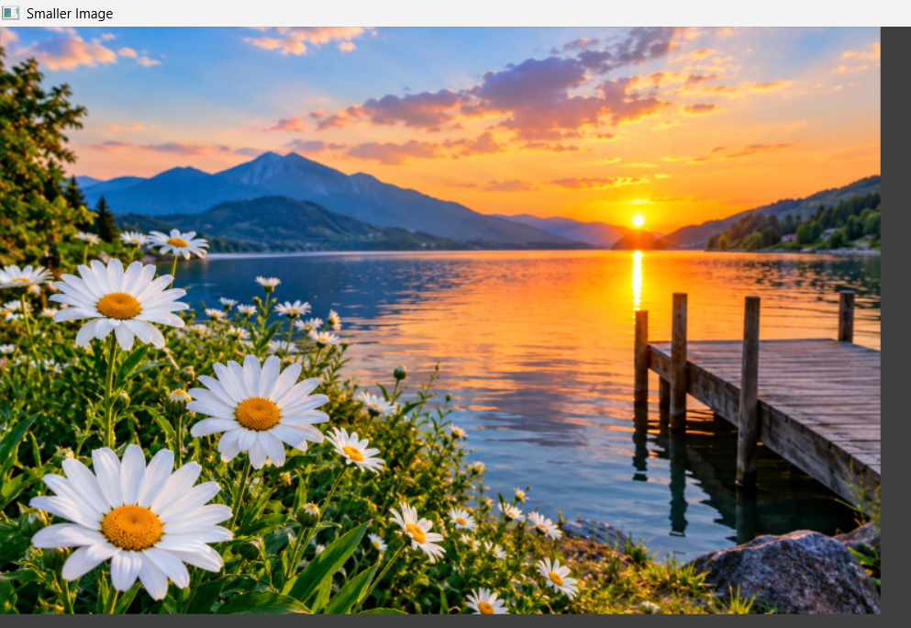
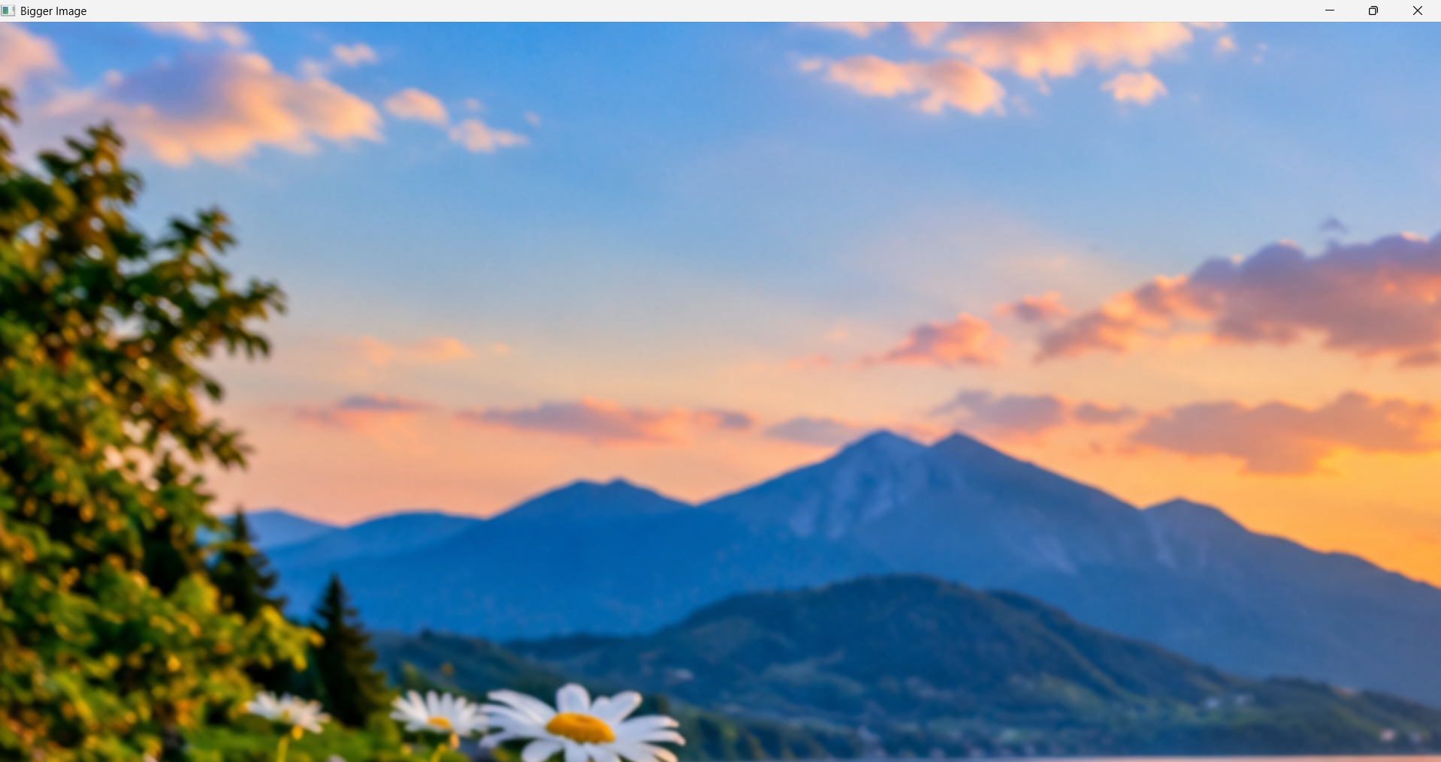
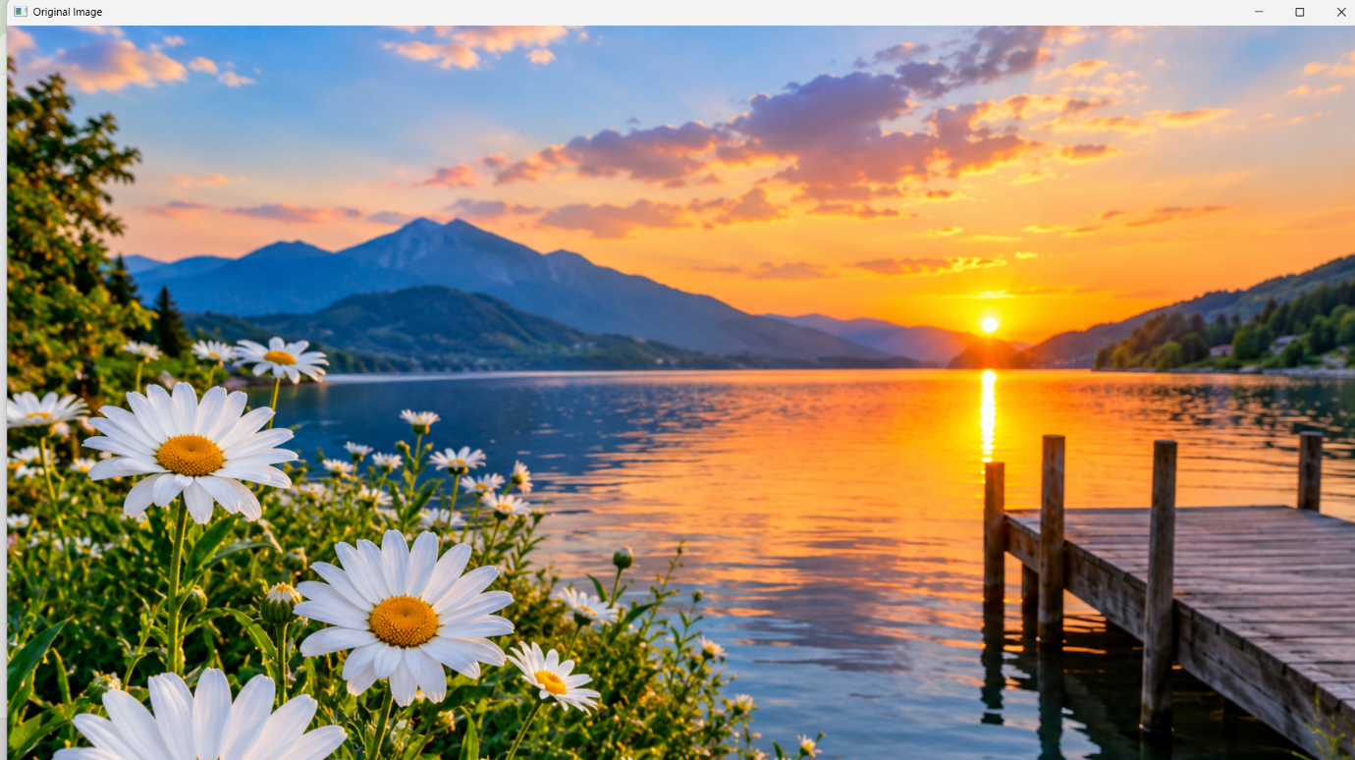

RESULT
Thus, image scaling was successfully implemented using OpenCV in Python to produce bigger and smaller versions of the input image.

